DESIGN AND DEVELOPMENT OF A COMPUTER-BASED SALES AND INVENTORY MANAGEMENT SYSTEM USING PYTHON

A PROJECT SUBMITTED IN PARTIAL FULFILLMENT OF THE REQUIREMENTS FOR THE AWARD OF A PROFESSIONAL CERTIFICATE IN MACHINE LEARNING, DATA SCIENCE, DATA LEARNING USING PYTHON PROGRAMMING AND MY SQL

BY

AKINLADE AYOMIKUN DORCAS

VALUEMAX CODERS’ HUB
30, OYO ROAD, OPPOSITE UNIVERSITY OF IBADAN POST OFFICE, IBADAN, NIGERIA
TUTOR: MR SAMUEL A. MISOJEUN

8TH JULY, 2026

DEDICATION
I humbly dedicate this project to God Almighty for His guidance, strength, and unwavering support throughout this academic journey.
To God be the Glory.

ACKNOWLEDGEMENT
First and foremost, I thank God Almighty for His guidance, wisdom, and strength throughout this project.
My heartfelt thanks go to my family for their encouragement and support throughout this journey. I also wish to express my sincere gratitude to Mr. Samuel A. Misojeun, my instructor at ValueMax Coders Hub for his invaluable guidance and support.

ABSTRACT
Inventory management remains one of the most critical aspects of business operations, particularly for small and medium-sized enterprises (SMEs). Many organizations continue to rely on manual inventory records, resulting in inaccurate stock counts, delayed replenishment decisions, financial losses, and poor customer satisfaction. This project presents the design and implementation of a Smart Inventory Management System developed using Python and Jupyter Notebook. The system integrates inventory monitoring, sales management, profit calculation, income tracking, automated low-stock alerts, and interactive data visualization into a single platform.
The application enables businesses to record products, monitor inventory levels, calculate sales revenue and profit automatically, and provide management with visual reports for informed decision-making. The dashboard displays inventory quantity, profit generated, and income actualization using charts, allowing users to quickly evaluate business performance.
The system further incorporates an automated alert mechanism that identifies products approaching minimum stock levels, enabling proactive inventory replenishment. Data are organized in structured tables while visual analytics provide an intuitive understanding of business operations.
The proposed system improves inventory accuracy, minimizes stock shortages, reduces human error, enhances operational efficiency, and supports strategic business decisions through real-time analytics. The implementation demonstrates that integrating inventory management with business intelligence tools significantly improves organizational productivity and profitability.

Keywords: Inventory Management, Python, Data Visualization, Sales Analytics, Business Intelligence, Profit Analysis, Stock Monitoring.

TABLE OF CONTENTS
Contents Page
Dedication i
Acknowledgements ii
Abstract iii
Table of Contents iv
Chapter One: Introduction 1
Chapter Two: Literature Review 5
Chapter Three: Methodology 9
Chapter Four: Results and Discussion 12
Chapter Five: Conclusion and Recommendations 15
References 17

CHAPTER ONE
INTRODUCTION
1.1 Background of the Study
Inventory constitutes one of the largest investments in most commercial organizations. Effective inventory management ensures that products are available when customers demand them while minimizing storage costs and reducing excess stock.
Traditional inventory systems often depend on handwritten records or spreadsheet applications that are prone to data duplication, calculation errors, and delayed reporting. As businesses expand, manual methods become increasingly inefficient, resulting in inaccurate stock records, revenue losses, and poor decision-making.
Advancements in information technology have enabled the development of intelligent inventory systems capable of automating stock monitoring, sales recording, financial calculations, and performance reporting. These systems provide managers with accurate, real-time information that facilitates effective planning and resource allocation.
This project develops a Smart Inventory Management System capable of automatically tracking inventory, computing profits and income, issuing stock alerts, and presenting business performance through graphical dashboards.

1.2 Problem Statement
Many businesses experience challenges such as:
- Inaccurate inventory records
- Difficulty tracking daily sales
- Delayed stock replenishment
- Poor financial monitoring
- Human errors during calculations
- Lack of visual business reports
- Time-consuming manual inventory auditing
These challenges reduce operational efficiency and profitability.

1.3 Aim of the Study
To develop a Smart Inventory Management System that automates inventory control, sales analysis, financial reporting, and visualization using Python.

1.4 Objectives
The objectives include:
- Develop an inventory database.
- Record product information.
- Monitor available stock.
- Calculate sales automatically.
- Compute income generated.
- Calculate profit earned.
- Detect products with low inventory.
- Generate graphical reports.
- Improve business decision-making.

1.5 Significance of the Study
The system benefits:
- Retail businesses
- Warehouses
- Supermarkets
- Pharmacies
- Small and Medium Enterprises (SMEs)
Benefits include:
- Faster inventory management
- Accurate stock records
- Reduced financial losses
- Better forecasting
- Improved customer satisfaction
- Data-driven decision making

1.6 Scope
The project covers:
- Product registration
- Sales recording
- Inventory tracking
- Profit computation
- Income analysis
- Low-stock alerts
- Dashboard visualization

1.7 Limitations
- Desktop implementation only
- Single-user environment
- Local database storage
- No online ordering integration

CHAPTER TWO
LITERATURE REVIEW
2.1 Inventory Management
Inventory management refers to planning, controlling, storing, and tracking goods to satisfy customer demand while minimizing operational costs.
According to Chopra and Meindl (Supply Chain Management), inventory management balances customer service and inventory investment.

2.2 Traditional Inventory Systems
Traditional inventory methods include:
- Manual stock books
- Paper records
- Spreadsheet systems
Advantages:
- Low cost
- Easy implementation
Disadvantages:
- Human error
- Data redundancy
- Poor scalability
- Slow reporting

2.3 Computerized Inventory Systems
Computerized systems automate:
- Stock updates
- Sales recording
- Report generation
- Profit calculation
Advantages include:
- High accuracy
- Faster processing
- Real-time monitoring
- Reduced workload

2.4 Data Visualization
Data visualization converts numerical information into graphical formats.
Common visualization techniques include:
- Pie charts
- Bar charts
- Line charts
- Dashboards
Visualization enables managers to identify trends quickly and make informed decisions.

2.5 Business Intelligence
Business Intelligence (BI) involves transforming raw business data into actionable insights.
The dashboard developed in this project functions as a lightweight BI tool by presenting:
- Sales performance
- Inventory utilization
- Profit analysis
- Income analysis

2.6 Python for Inventory Management
Python was selected because of:
- Simplicity
- Extensive libraries
- Data analysis capability
- Visualization support
- Automation features
Libraries used include:
- Pandas
- NumPy
- Matplotlib

2.7 Related Works
Several researchers have proposed inventory management systems focusing on:
- Barcode technology
- RFID tracking
- Cloud inventory
- ERP systems
However, many solutions are expensive and complex for SMEs. This project provides an affordable desktop alternative with integrated analytics.

CHAPTER THREE
METHODOLOGY
3.1 Research Method
The project adopted the Object-Oriented Software Development Methodology, involving:
- Requirement analysis
- System design
- Implementation
- Testing
- Evaluation
3.2 System Architecture
User Inventory Database Python Processing Engine Sales Module Profit Calculation Income Calculation Low Stock Detection Dashboard Visualization Reports

3.3 Development Tools
Tool | Purpose
Python | Programming Language
Pandas | Data Management
NumPy | Mathematical Computation
Matplotlib | Charts
Jupyter Notebook | Development Environment
3.4 Database Design
The inventory table contains:
Field | Description
Product ID | Unique identifier
Product Name | Item name
Quantity | Available stock
Cost Price | Purchase cost
Selling Price | Selling price
Profit | Calculated profit
Income | Sales income

3.5 System Modules
Inventory Module
Responsible for:
- Adding products
- Updating products
- Deleting products
- Viewing inventory

Sales Module
Responsible for:
- Recording sales
- Updating inventory
- Computing income
Profit Module
Computes:
Profit = Selling Price − Cost Price
Income Module
Calculates
Income = Selling Price × Quantity Sold

CHAPTER FOUR
RESULTS AND DISCUSSION
4.1 Dashboard Analysis
The dashboard generated by the system presents three key business indicators.
  - Quantity Analysis
For example:
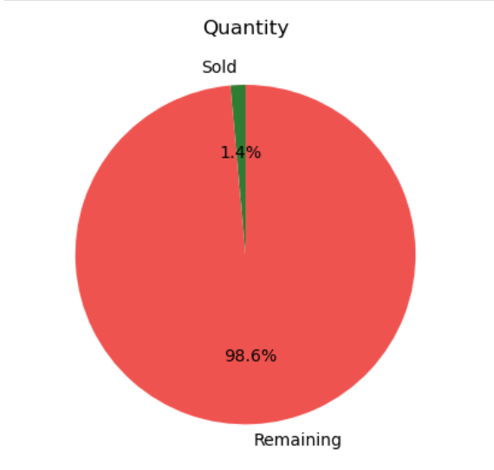
- Sold = 1.4%
- Remaining = 98.6%
This indicates inventory is still largely available.
  - Profit Analysis
For example:
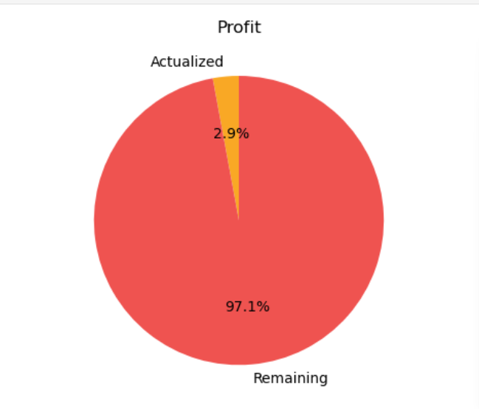
- Actualized Profit = 2.9%
- Remaining Potential Profit = 97.1%
This demonstrates that only a small portion of the expected profit has been realized.
  - Income Analysis
For example:
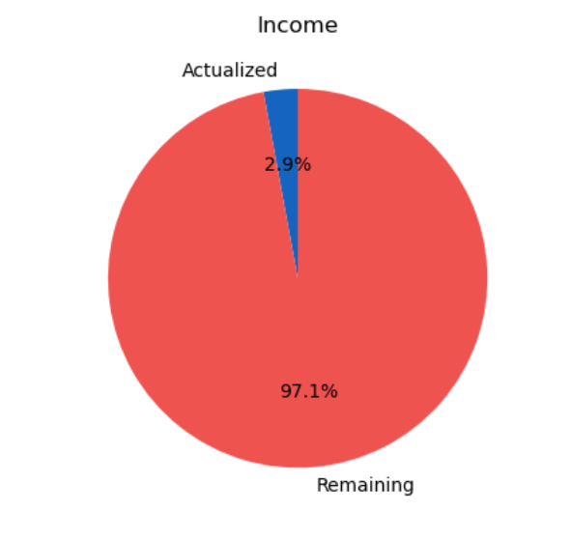

- Actualized Income = 2.9%
- Remaining Revenue Opportunity = 97.1%
The dashboard shows that additional sales efforts are required.

4.2 Low Stock Alert
The system automatically identifies products nearing depletion.
This feature assists businesses in avoiding stock-outs and maintaining continuous product availability.

4.3 Overall Performance
The dashboard provides management with:
- Inventory status
- Business growth
- Sales performance
- Profit realization
- Revenue monitoring
The graphical interface significantly improves managerial decision-making compared with traditional spreadsheet reports.

CHAPTER FIVE
CONCLUSION AND RECOMMENDATIONS
5.1 Conclusion
The system successfully demonstrates how Python can be used to automate inventory control, sales tracking, profit computation, income analysis, and business reporting.
The developed application reduces human error, improves efficiency, and provides real-time insights through interactive visualizations. The automated alert mechanism ensures timely stock replenishment while the dashboard assists managers in making informed operational decisions.
The project achieves its objectives and provides an affordable inventory solution suitable for SMEs.

5.2 Recommendations
Future improvements include:
- Cloud database integration
- Barcode scanning
- QR code support
- Mobile application
- Multi-user authentication
- AI-based demand forecasting
- Automatic purchase order generation
- Web-based deployment
- Email/SMS stock alerts
- Interactive dashboards using Plotly or Power BI

Contributions to Knowledge
This research contributes by:
- Integrating inventory management with real-time analytics.
- Combining stock monitoring, sales, profit, and income tracking in one system.
- Providing automated low-stock detection.
- Delivering an intuitive dashboard for business intelligence.
- Demonstrating a low-cost Python-based solution suitable for SMEs.

REFERENCES
Chopra, S., & Meindl, P. (2019). Supply Chain Management: Strategy, Planning, and Operation (7th ed.). Pearson.
Heizer, J., Render, B., & Munson, C. (2020). Operations Management (13th ed.). Pearson.
McKinney, W. (2022). Python for Data Analysis (3rd ed.). O'Reilly Media.
Wes McKinney. (2022). Python for Data Analysis. O'Reilly.
Van Rossum, G., & Drake, F. L. (2009). Python 3 Reference Manual. CreateSpace.
Hunter, J. D. (2007). Matplotlib: A 2D Graphics Environment. Computing in Science & Engineering, 9(3), 90–95.

